Problem No: 3

Problem Statement:
Write a MATLAB program to compute and display the 2D linear convolution of two user-defined 2D matrices (an input signal/image A and a kernel H) from scratch, using zero-padding and four nested loops for manual implementation instead of built-in functions. The program should also visualize the input matrices, kernel, and resulting 2D convolution output using color-scaled image plots.

Codes:
clc;
clear;
close all;

% Input 2D matrices (images / spatial signals)
A = input("Enter the first 2D matrix A = ");
H = input("Enter the second 2D matrix H (kernel) = ");

[rA, cA] = size(A);
[rH, cH] = size(H);

% Flip the kernel 180 degrees for true 2D convolution (transposed feel)
H_flipped = rot90(H, 2);

% Output dimensions for full 2D convolution
rOut = rA + rH - 1;
cOut = cA + cH - 1;

% Zero-pad matrix A to handle boundaries
padA = zeros(rA + 2*(rH - 1), cA + 2*(cH - 1));
padA(rH : rH + rA - 1, cH : cH + cA - 1) = A;

% Initialize output matrix C
C = zeros(rOut, cOut);

% Manual 2D convolution using 4 nested for-loops
for i = 1 : rOut
for j = 1 : cOut
sum_val = 0;
for p = 1 : rH
for q = 1 : cH
sum_val = sum_val + padA(i + p - 1, j + q - 1) * H_flipped(p, q);
endfor
endfor
C(i, j) = sum_val;
endfor
endfor

disp("2D Convolution output C is = ");
disp(C);

% Visualization using subplots and image plots
figure;

subplot(2, 2, 1);
imagesc(A);
colorbar;
xlabel('Columns');
ylabel('Rows');
title('Matrix A');

subplot(2, 2, 2);
imagesc(H);
colorbar;
xlabel('Columns');
ylabel('Rows');
title('Kernel H');

subplot(2, 1, 2);
imagesc(C);
colorbar;
xlabel('Columns');
ylabel('Rows');
title('2D Convolution Output C');

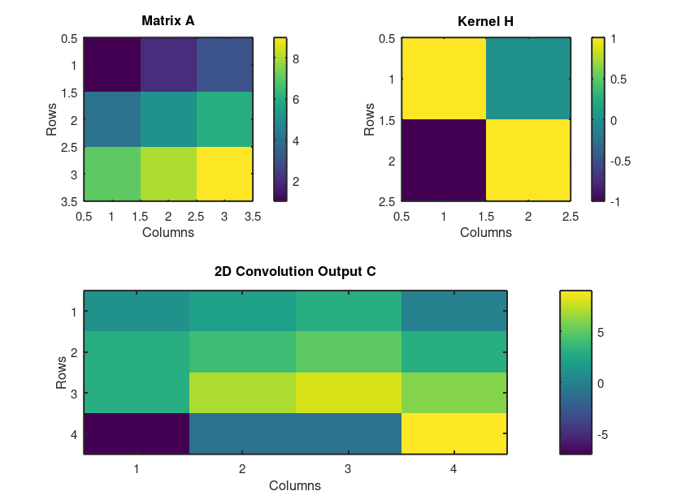
Output:

